Determiner

🔵 What is a Determiner?
# Source: AI Source: Provided by: [Data Path: Persons Table -> ID Column: 1, Name_En Column: Motasem Essam] -> From: [Chatgpt (GPT-4-turbo)] on [7/24/2025]
A determiner is a word that comes before a noun to show which one, how many, whose, or what kind.
It helps us be more specific about the noun that follows.

📘 Definition:
# Source: AI Source: Provided by: [Data Path: Persons Table -> ID Column: 1, Name_En Column: Motasem Essam] -> From: [Chatgpt (GPT-4-turbo)] on [7/24/2025]
A determiner is a word placed in front of a noun to introduce it and give more information about what the noun refers to — such as quantity, ownership, or specificity.

🧠 Common Types of Determiners:
# Source: AI Source: Provided by: [Data Path: Persons Table -> ID Column: 1, Name_En Column: Motasem Essam] -> From: [Chatgpt (GPT-4-turbo)] on [7/24/2025]
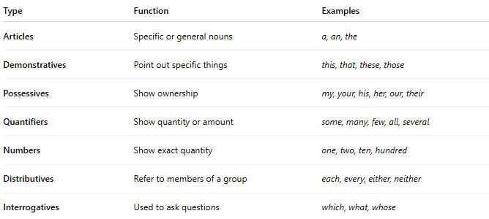
Type | Function | Examples
Articles | Specific or general nouns | a, an, the
Demonstratives | Point out specific things | this, that, these, those
Possessives | Show ownership | my, your, his, her, our, their
Quantifiers | Show quantity or amount | some, many, few, all, several
Numbers | Show exact quantity | one, two, ten, hundred
Distributives | Refer to members of a group | each, every, either, neither
Interrogatives | Used to ask questions | which, what, whose

✳️ Examples in Sentences:
# Source: AI Source: Provided by: [Data Path: Persons Table -> ID Column: 1, Name_En Column: Motasem Essam] -> From: [Chatgpt (GPT-4-turbo)] on [7/24/2025]
- The cat is sleeping. (article)
- I want some water. (quantifier)
- This book is mine. (demonstrative)
- That is my car. (possessive)
- Every student must participate. (distributive)
- Which color do you prefer? (interrogative)

⚠️ Important:
# Source: AI Source: Provided by: [Data Path: Persons Table -> ID Column: 1, Name_En Column: Motasem Essam] -> From: [Chatgpt (GPT-4-turbo)] on [7/24/2025]
- Determiners always come before nouns (and before adjectives if there are any).
  - ✅ The big dog barked.
  - ❌ Big the dog barked.

Determiners vs Adjectives
# Source: AI Source: Provided by: [Data Path: Persons Table -> ID Column: 1, Name_En Column: Motasem Essam] -> From: [Chatgpt (GPT-4-turbo)] on [7/24/2025]
These two word classes are similar because both come before nouns, but they serve different grammatical roles.

✅ 1. What Are Determiners?
# Source: AI Source: Provided by: [Data Path: Persons Table -> ID Column: 1, Name_En Column: Motasem Essam] -> From: [Chatgpt (GPT-4-turbo)] on [7/24/2025]
Determiners are words placed in front of a noun to show:
- Which one?
- Whose?
- How many?
- Whether it's specific or general
They help identify or limit the noun.
Examples:
- this car
- my book
- some water
- five dogs
- the house

✅ 2. What Are Adjectives?
# Source: AI Source: Provided by: [Data Path: Persons Table -> ID Column: 1, Name_En Column: Motasem Essam] -> From: [Chatgpt (GPT-4-turbo)] on [7/24/2025]
Adjectives are words that describe the qualities, features, or characteristics of nouns.
They answer:
- What kind?
- Which one?
- How does it look/sound/feel?
Examples:
- red car
- interesting book
- large house
- sweet mango
- happy child

🔁 Key Differences:
# Source: AI Source: Provided by: [Data Path: Persons Table -> ID Column: 1, Name_En Column: Motasem Essam] -> From: [Chatgpt (GPT-4-turbo)] on [7/24/2025]
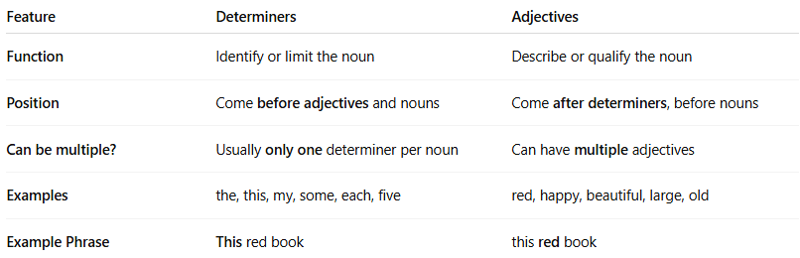
Feature | Determiners | Adjectives
Function | Identify or limit the noun | Describe or qualify the noun
Position | Come before adjectives and nouns | Come after determiners, before nouns
Can be multiple? | Usually only one determiner per noun | Can have multiple adjectives
Examples | the, this, my, some, each, five | red, happy, beautiful, large, old
Example Phrase | This red book | this red book

🧩 Example Sentence Breakdown:
# Source: AI Source: Provided by: [Data Path: Persons Table -> ID Column: 1, Name_En Column: Motasem Essam] -> From: [Chatgpt (GPT-4-turbo)] on [7/24/2025]
This beautiful dress is new.
- “This” = determiner (which dress?)
- “Beautiful” = adjective (what kind of dress?)

✅ Conclusion:
# Source: AI Source: Provided by: [Data Path: Persons Table -> ID Column: 1, Name_En Column: Motasem Essam] -> From: [Chatgpt (GPT-4-turbo)] on [7/24/2025]
- Determiner = limits the noun
- Adjective = describes the noun
- You often see both together, but they are not the same thing.

✅ Summary:
# Source: AI Source: Provided by: [Data Path: Persons Table -> ID Column: 1, Name_En Column: Motasem Essam] -> From: [Chatgpt (GPT-4-turbo)] on [7/24/2025]
A determiner is a word used before a noun to give more information about it — such as how many, whose, or which one.

